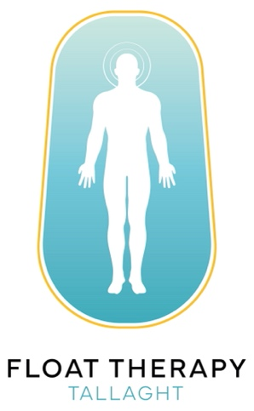

Hello & Welcome to Float Therapy Tallaght

Online Waiver

- I hereby confirm that I am using the floatation facilities at my own risk.

- I am not wearing a pacemaker and do not have any serious heart disease.

- I have not had my hair dyed in the last 7days.

- I will only use hair products (shampoo etc.) supplied by Float Therapy Tallaght before my float.

- I do not suffer from epilepsy or psychotic attacks.

- I am not under the influence of drugs, alcohol or illegal substances.

- I also confirm that I have no history of ear infections.

